Maintaining state through multiple form
Prepared: TrangNTT
Lab 10. Maintaining state through multiple form 1
10.1. Run the example in lecture slides 2
10.2. Preference selection using COOKIE 2
10.3. Preference selection using SESSION 4
10.4. Manage Login session 5
10.5. Exercise 7

Run the example in lecture slides
            - Using Hidden fields: Happy Harry’s Hardware Product Order: order.html, order2.php, order3.php.
            - Using Browser cookies: survey.html, setcookie.php, readcookie.php
            - PHP session: ordersession.php, sessions2order.php, sessions3order.php

Preference selection using COOKIE

PrefSelection.html
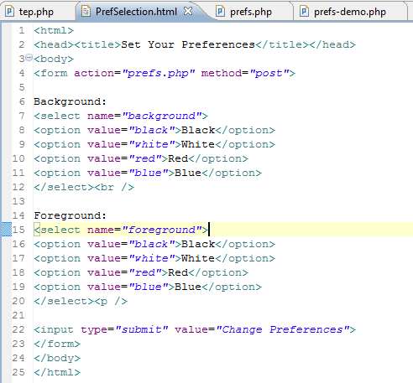

Prefs.php
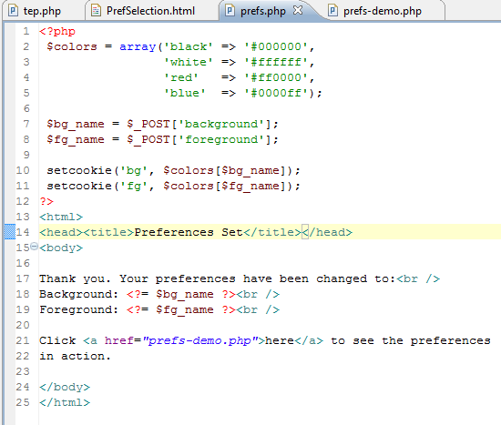

prefs-demo.php
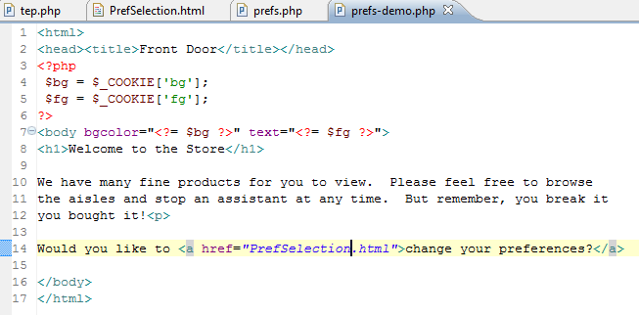

Result
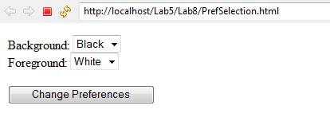
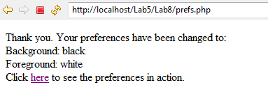
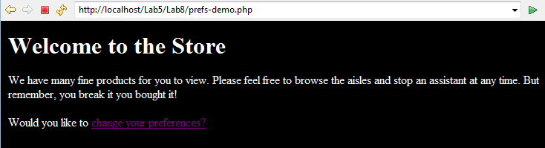

Preference selection using SESSION
Modify processing php files using session. The following is only the suggestion; you have to work around on it to do this exercise:
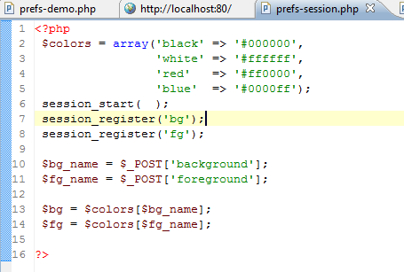
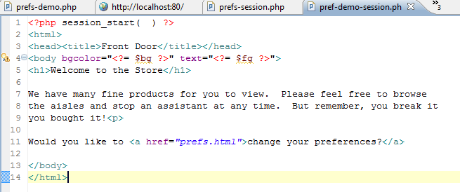

Manage Login session

Create database & table
- Create a database named Lab12 then create table in this database named Users.
CREATE TABLE Users (
UserName varchar(50),
Password varchar(30) NOT NULL,
DisplayName varchar(100) character set UTF8 NOT NULL,
Email varchar(50) NOT NULL,
PhoneNumber varchar(10)
);
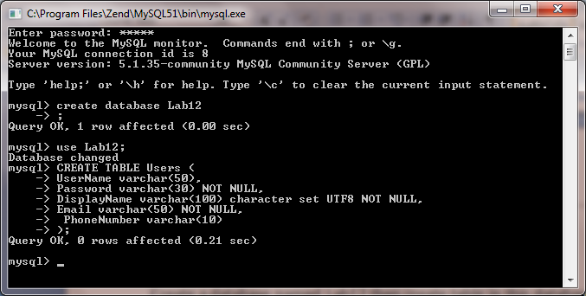
- Modify the Users table using phpMyAdmin: UserName is the PRIMARY KEY, Email is the UNIQUE KEY.
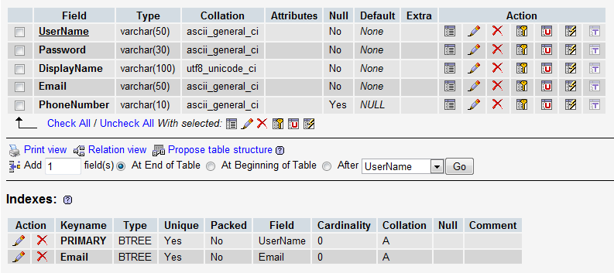
- Insert some data for Users table; note that DisplayName should be entered in Vietnamese.
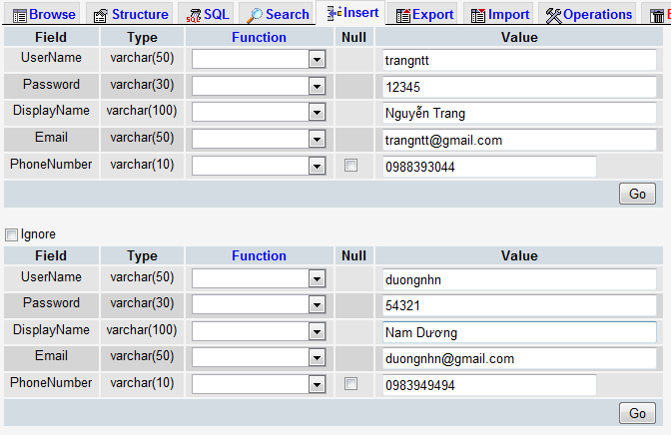
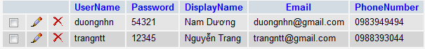

Create login.php
- Allow users to enter his/her UserName and Password
- Check if the UserName and the Password are existed in the Users table or not
  - If both existed (login successfully), display Welcome page and the UserName should be written into session
  - If not matched (login fail), display Error in red color.

Create check_login.php to check if there is any UserName session. If No, redirect to the login.php page; otherwise stay at the current page.

Modify the prefs-session.php and prefs-demo-session.php in 9.3
- Includes check_login.php file to require the user log in before enter the page. Run to see the result.
- Add/modify heading 1 (h1) welcome to “HI $USERNAME, WELCOME TO THE STORE”, where $USERNAME is retrieved from the UserName session. Run again to see the result.

Exercise
Building a shopping cart application which allows users to choose products (Microsoft software like MSDNAA Program) then add them to cart. Then, users can view the cart; they can modify or delete a product in the cart.

